

Azure Site Recovery (ASR) Deployment Guide
Hyper-V Standalone Hosts

10th Magnitude, LLC
20 North Wacker Drive #530
Chicago, IL 60606

Notice of Confidentiality © 2018 10th Magnitude, LLC All rights reserved

THIS DOCUMENT IS 10TH MAGNITUDE PROPRIETARY AND CONFIDENTIAL INFORMATION AND IS SUBJECT TO THE TERMS OF THE 10TH MAGNITUDE NON-DISCLOSURE AGREEMENT. NEITHER THIS DOCUMENT NOR ITS CONTENTS MAY BE REVEALED OR DISCLOSED TO UNAUTHORIZED PERSONS OR SENT OUTSIDE THE AFOREMENTIONED COMPANY WITHOUT PRIOR PERMISSION FROM 10TH MAGNITUDE.
Table of Contents
Summary 3
ASR Deployment 3
Prepare On-Prem and Azure Environments 4

Summary
This is a general high-level step-by-step guide for deploying Azure Site Recovery (ASR) Hyper-V standalone specific on-prem environment.

ASR Deployment
Before you start, it’s a good idea to review the Microsoft ASR Setup Guide to get a clear understanding of the architecture and what needs to be deployed to support the migration.

Useful reference links:
https://docs.microsoft.com/en-us/azure/cloud-solution-provider/migration/on-premises-to-azure-csp/asr-capacity-planning
https://docs.microsoft.com/en-us/azure/cloud-solution-provider/migration/on-premises-to-azure-csp/asr-setup-guide
https://docs.vmware.com/en/VMware-vSphere/6.5/com.vmware.vsphere.vm_admin.doc/GUID-17BEDA21-43F6-41F4-8FB2-E01D275FE9B4.html

Prepare On-Prem and Azure Environments
- Create Resource Group in each target subscription and region for the Recovery Service Vault(s)
- Create a Recovery Services Vault in the target region(s)
  - Sign into the Azure Portal
  - Select New > Management > Backup and Site Recovery
  - Create a name to convention, select the correct Subscription and Resource Group, select the correct target location
  - Optionally select pin to dashboard for quick navigation back
- Prepare the ASR Infrastructure
  - In the Azure portal, open the Recovery Service vault
  - In the Site Recovery section, click Getting Started, then Prepare Infrastructure

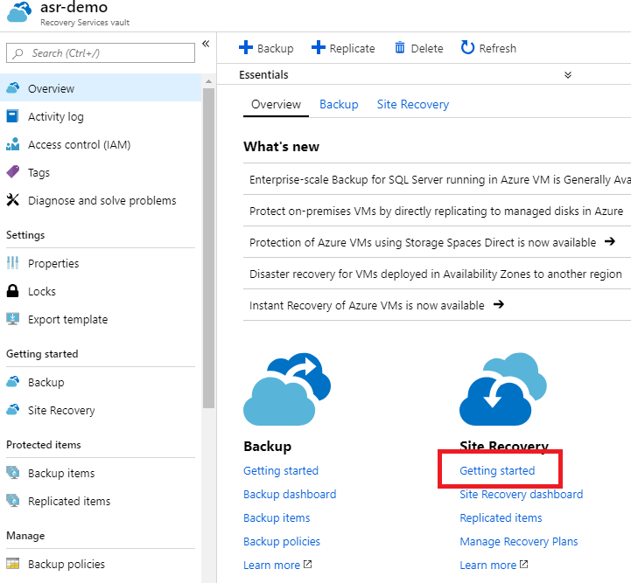

  - In the Protection goal step > Where are your machines located, select On-premises. Where do you want to replicate your machines, select To Azure. Are your machines virtualized, select Yes, with Hyper-V. Click OK. Are you using System Center VMM to manage your Hyper-V hosts? Select No.

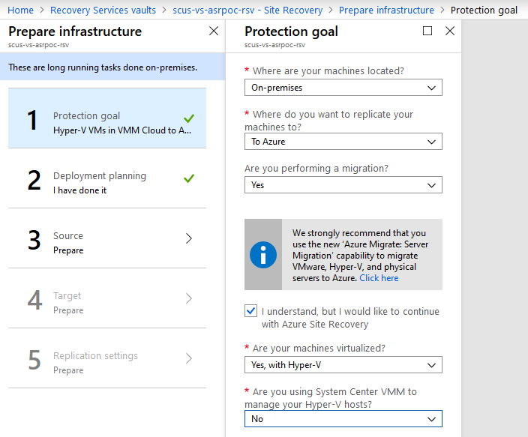

  - Deployment Planning > Yes, I have done it. Click OK.

  - Prepare the source environment by creating a new Hyper-V site. This should be a logical association to a data center location or physical site. If migrating from multiple sites, then you should create multiple sites and run this configuration per site.

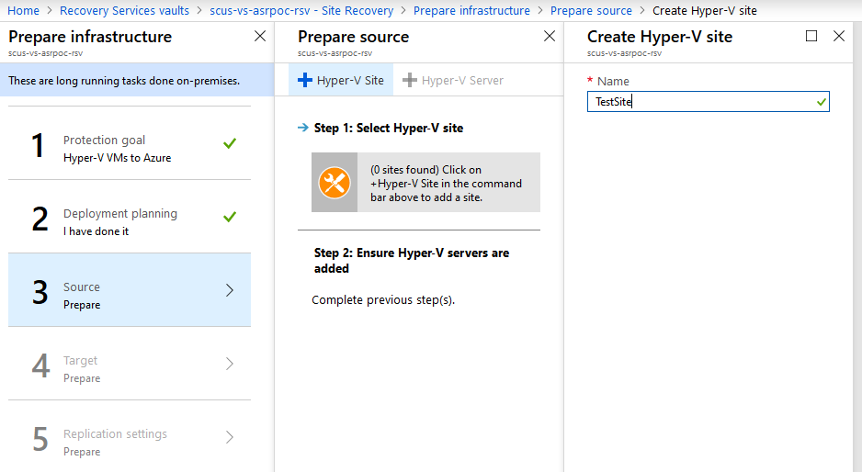

  - After the site has been created, you can add your Hyper-V servers. You’ll need to install the ASR provider on the hosts and register them in the Recovery Services Vault.
    - Make sure the hosts are running Windows Server 2012 R2 or above.
    - Check that Hyper-V hosts are assigned to appropriate VMM cloud
    - Configure Proxy Settings so that Hyper-V host can access Service URLs
    - Download the installer for the Microsoft Azure Recovery Services agent
    - Download the Vault Registration Key and save it.
    - Run the installer on each Hyper-V server in the VMM cloud to install the agent and use the registration key when prompted to register the host in the Recovery Services Vault.

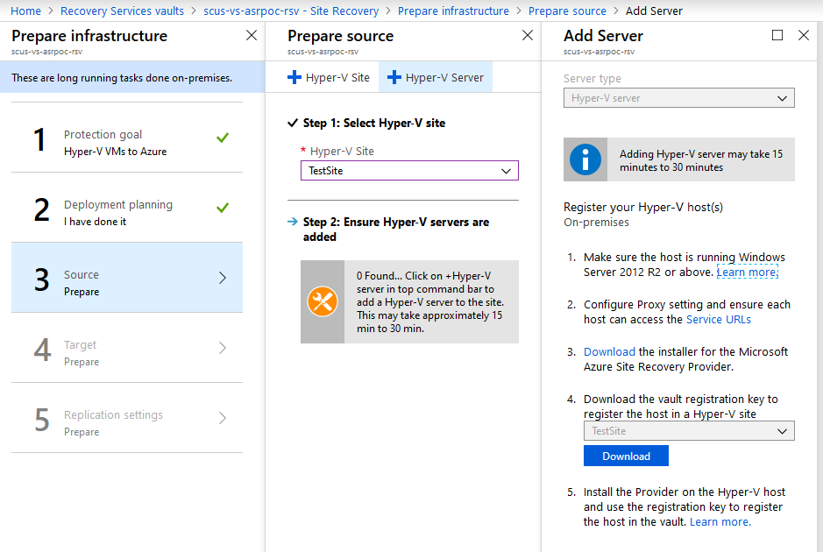
ASR provider host installation using install defaults:

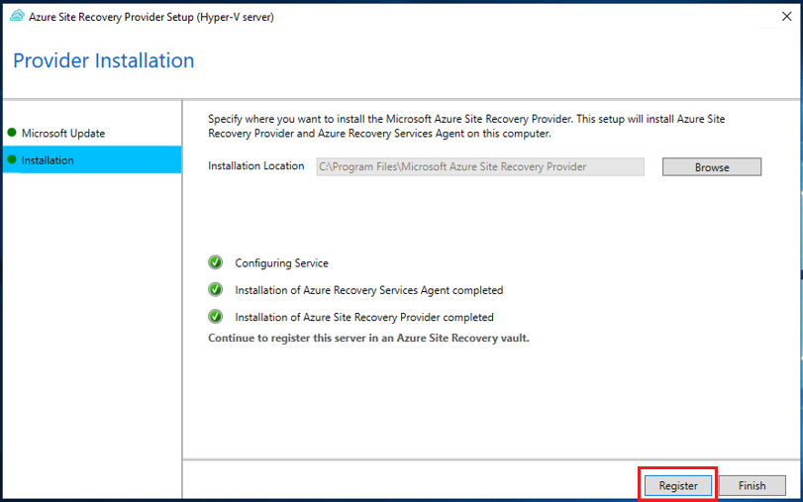
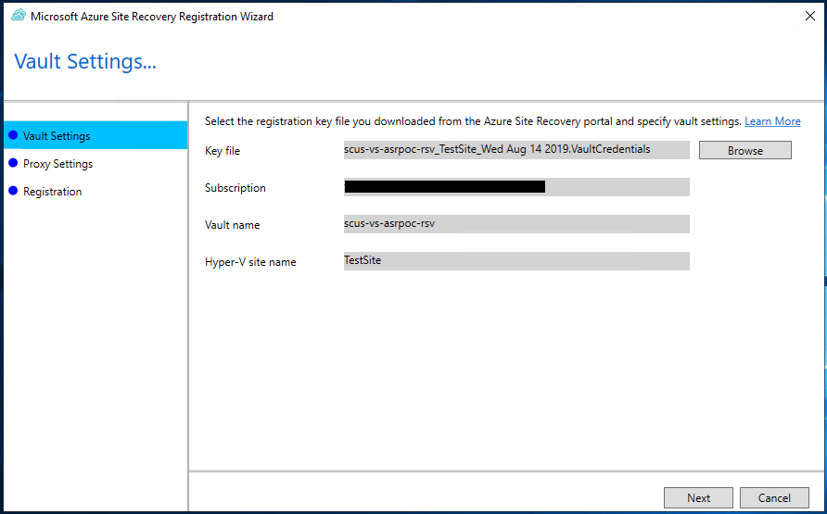

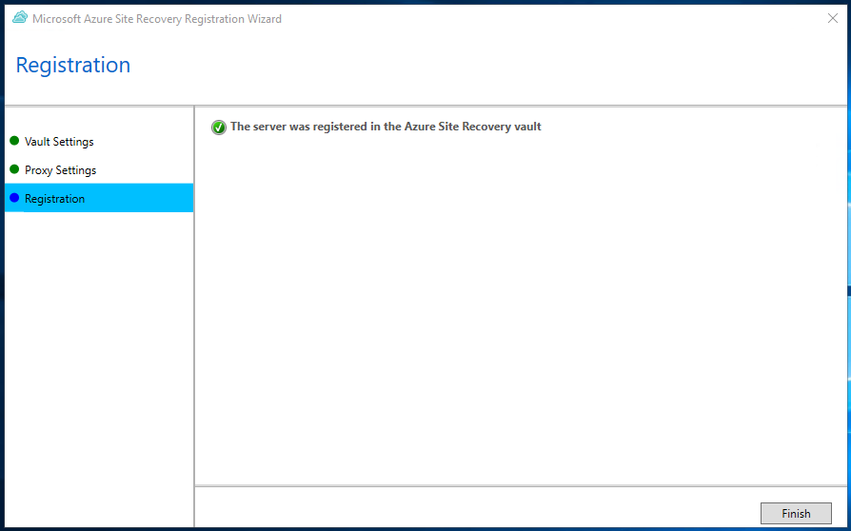

  - Now that the agent has been installed on the host(s), they should be available to add. This can take some time, up to 15 mintues. You may have to exit out of the prepare infrastructure wizard and restart it to pick up the new hosts.

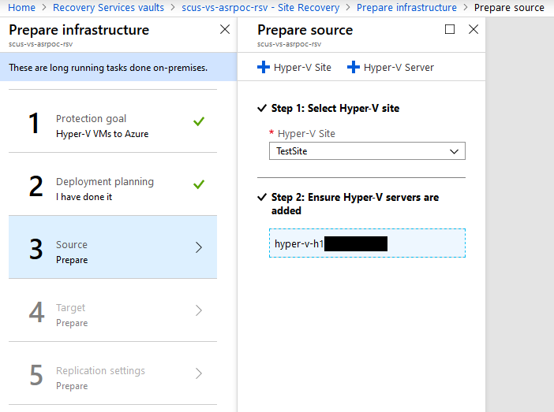
  - Next, you’ll need to configure your target environment. Select the target subscription and optionally a storage account and network. These can be configured later, but you’ll need at least one compatible storage account and network. If these don’t exist, you can create them from this wizard.

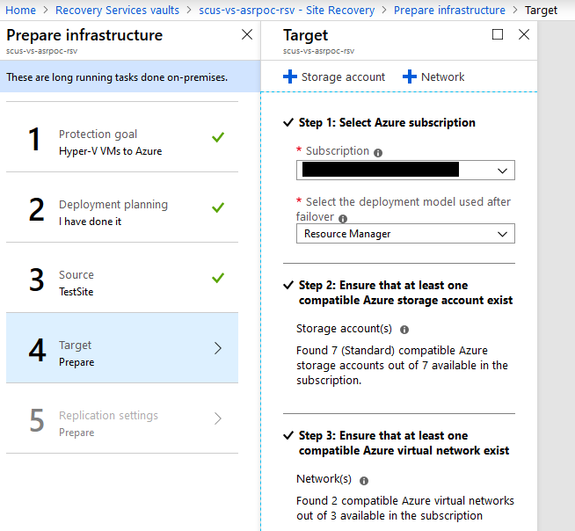

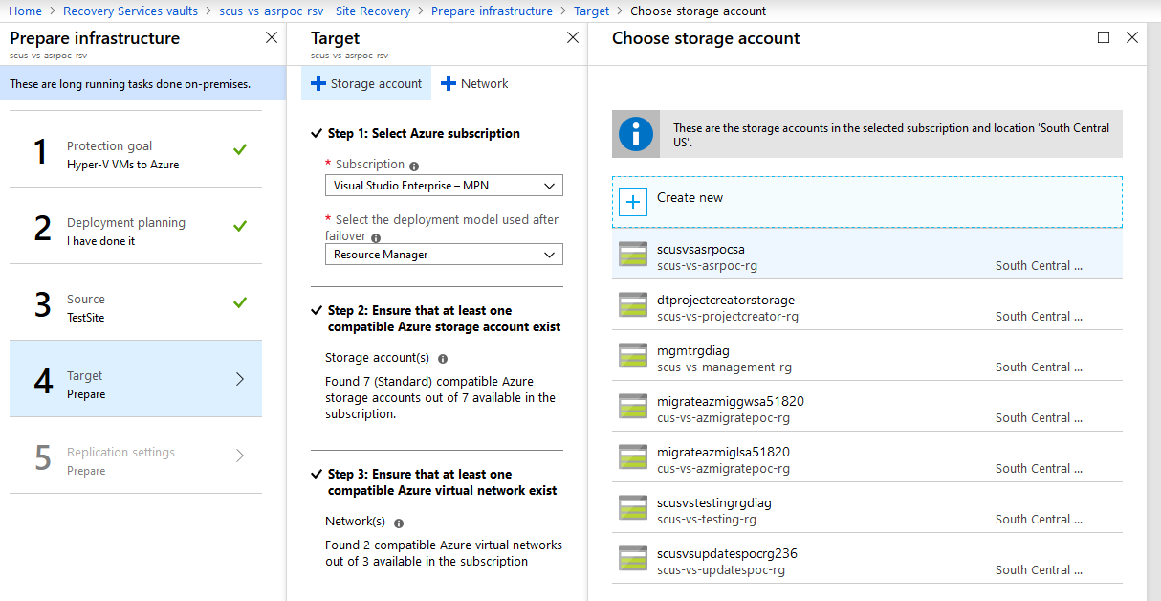

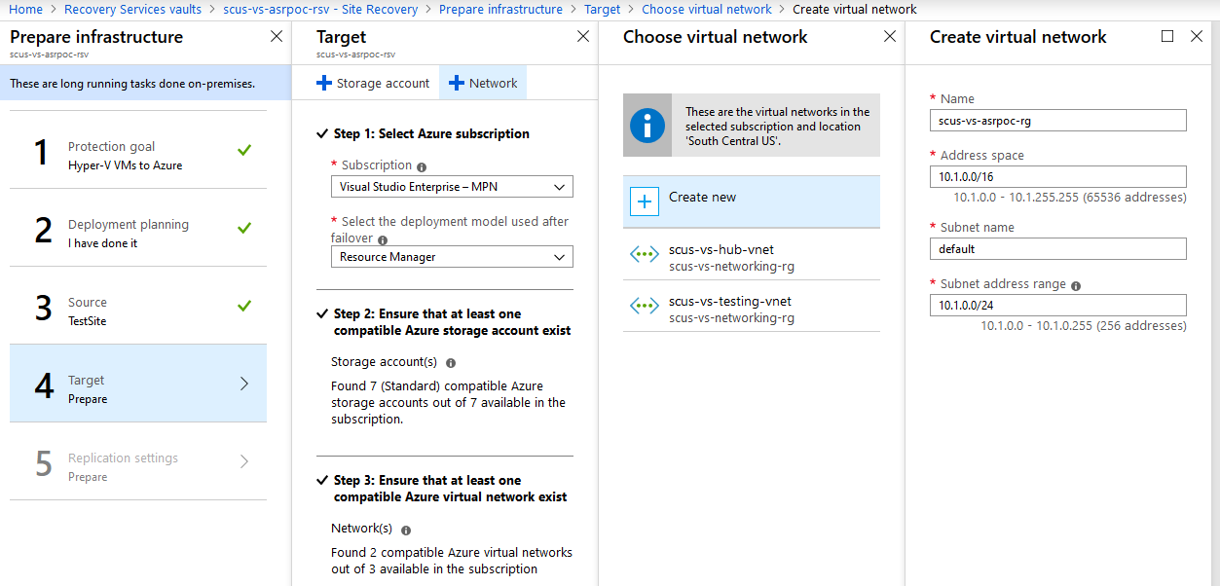

  - Lastly, create and associate a replication policy that meets the RPO target, or you can associate an existing policy by clicking the Associate button.

